SQL TASK 1

Create database task1;
CREATE TABLE Employee (
Employee_ID INT,
Employee_Name VARCHAR(100),
Department VARCHAR(50),
Salary DECIMAL(10,2),
Hire_Date DATE
);
INSERT INTO Employee (Employee_ID, Employee_Name, Department, Salary, Hire_Date) VALUES
(101, 'Aarav Sharma', 'IT', 85000, '2026-03-15'),
(102, 'Priya Verma', 'HR', 60000, '2025-11-10'),
(103, 'Rohan Gupta', 'Finance', 92000, '2026-05-01'),
(104, 'Neha Singh', 'Marketing', 70000, '2025-08-20'),
(105, 'Karan Patel', 'IT', 95000, '2026-02-10'),
(106, 'Sneha Joshi', 'Sales', 55000, '2026-06-05'),
(107, 'Rahul Mehta', 'Operations', 65000, '2025-12-01'),
(108, 'Ananya Das', 'Finance', 92000, '2026-04-18'),
(109, 'Vikram Rao', 'IT', 78000, '2025-10-15'),
(110, 'Pooja Nair', 'Sales', 55000, '2026-06-05');

#1. Top 5 Highest Salary Employees
SELECT *
FROM Employee
ORDER BY Salary DESC
LIMIT 5;
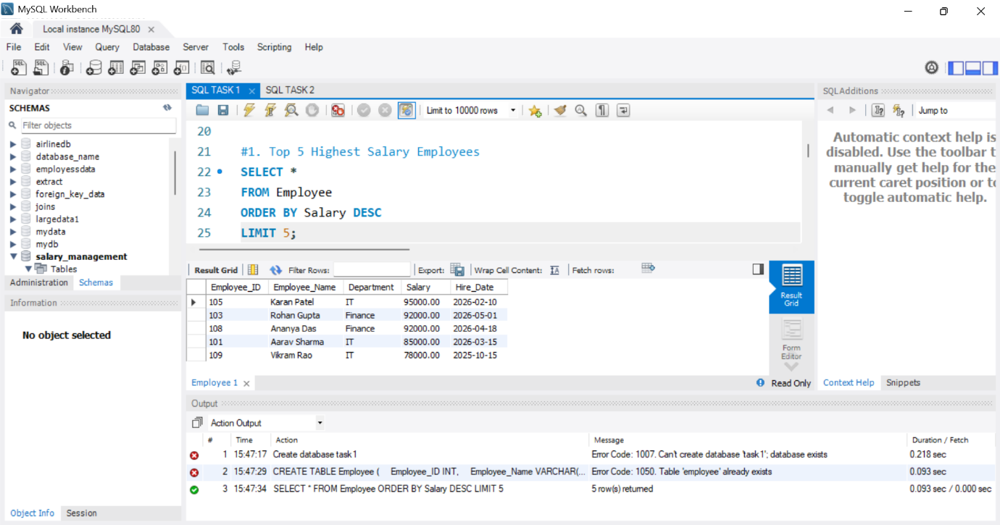

#2. Department-wise Employee Count
SELECT Department, COUNT(*) AS Employee_Count
FROM Employee
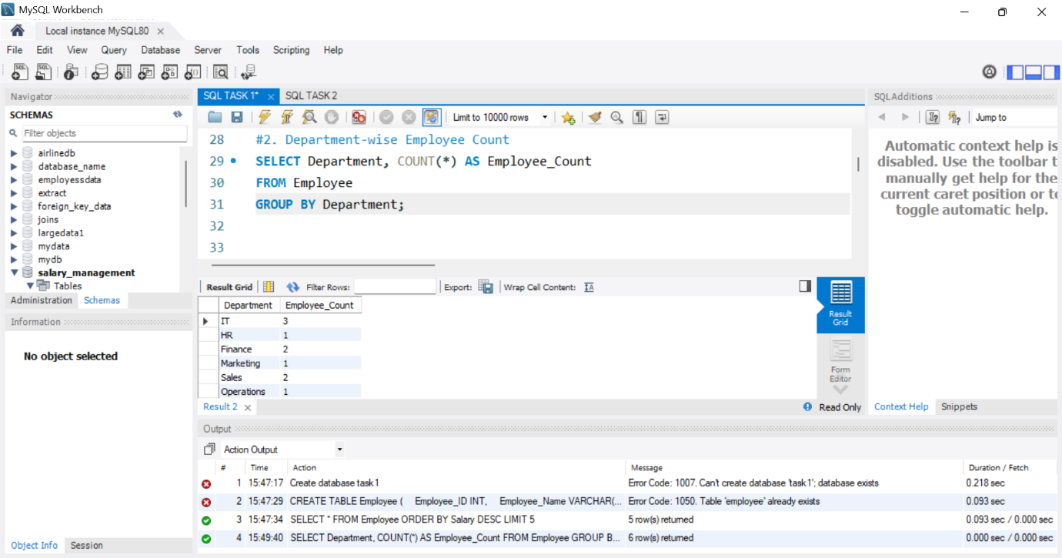
GROUP BY Department;

#3. Find the Second Highest Salary
SELECT MAX(Salary) AS Second_Highest_Salary
FROM Employee
WHERE Salary < (
SELECT MAX(Salary)
FROM Employee
);

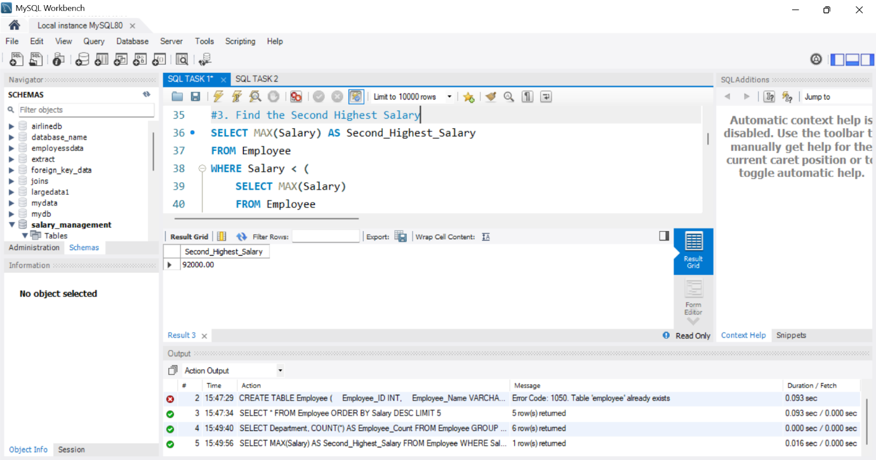

#4. Employees Whose Salary is Greater Than Their Department Average Salary
SELECT Employee_ID,
Employee_Name,
Department,
Salary
FROM Employee e
WHERE Salary >
(
SELECT AVG(Salary)
FROM Employee
WHERE Department = e.Department
);

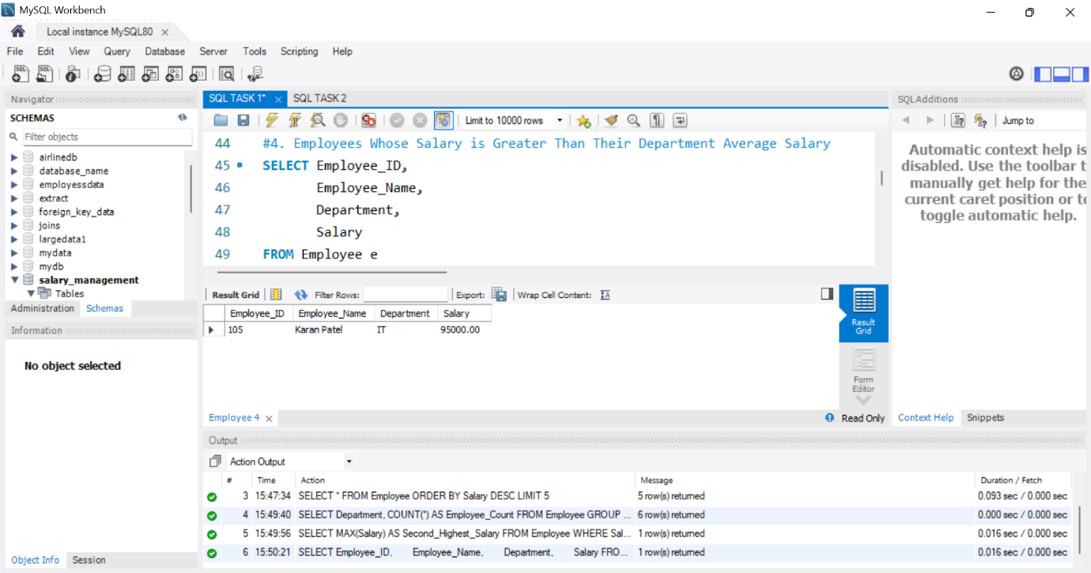

#5. INNER JOIN
SELECT
e.Employee_ID,
e.Employee_Name,
e.Department,
d.Department
FROM Employee e
INNER JOIN Department d
ON e.Department = d.Department;

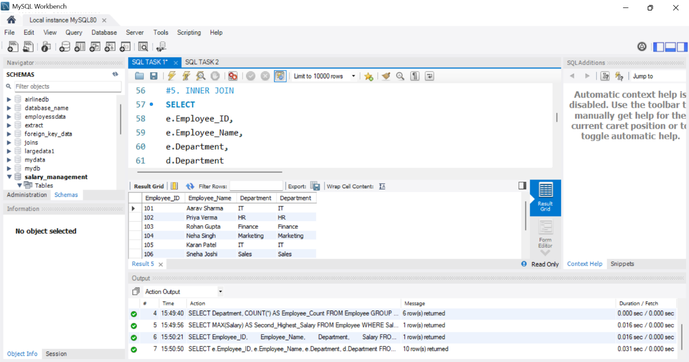

#6. LEFT JOIN
SELECT
e.Employee_ID,
e.Employee_Name,
e.Department,
d.Department
FROM Employee e
LEFT JOIN Department d
ON e.Department = d.Department;
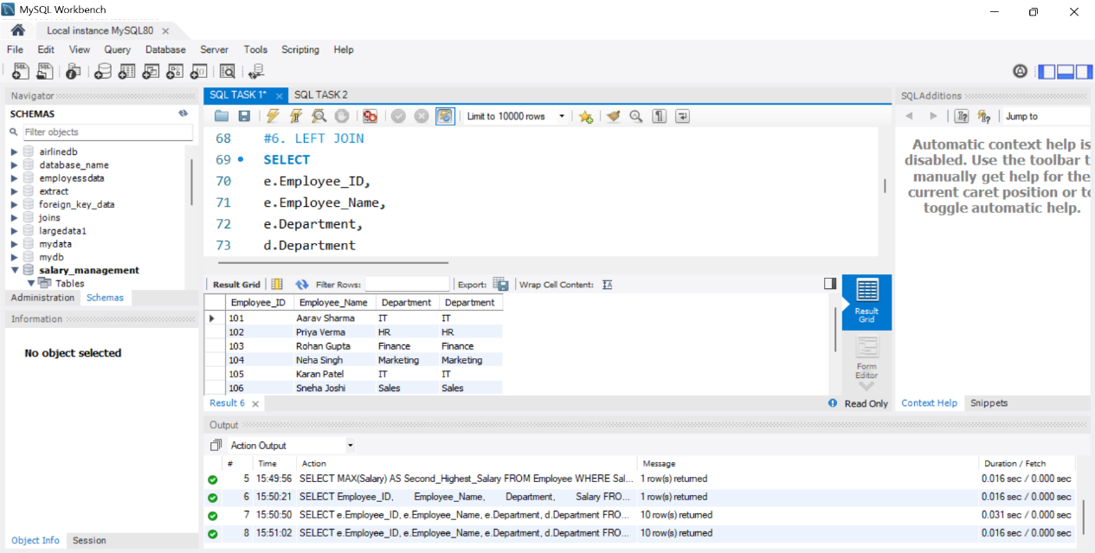

#7. GROUP BY with HAVING
SELECT
Department,
COUNT(*) AS Total_Employees
FROM Employee
GROUP BY Department
HAVING COUNT(*) > 1;
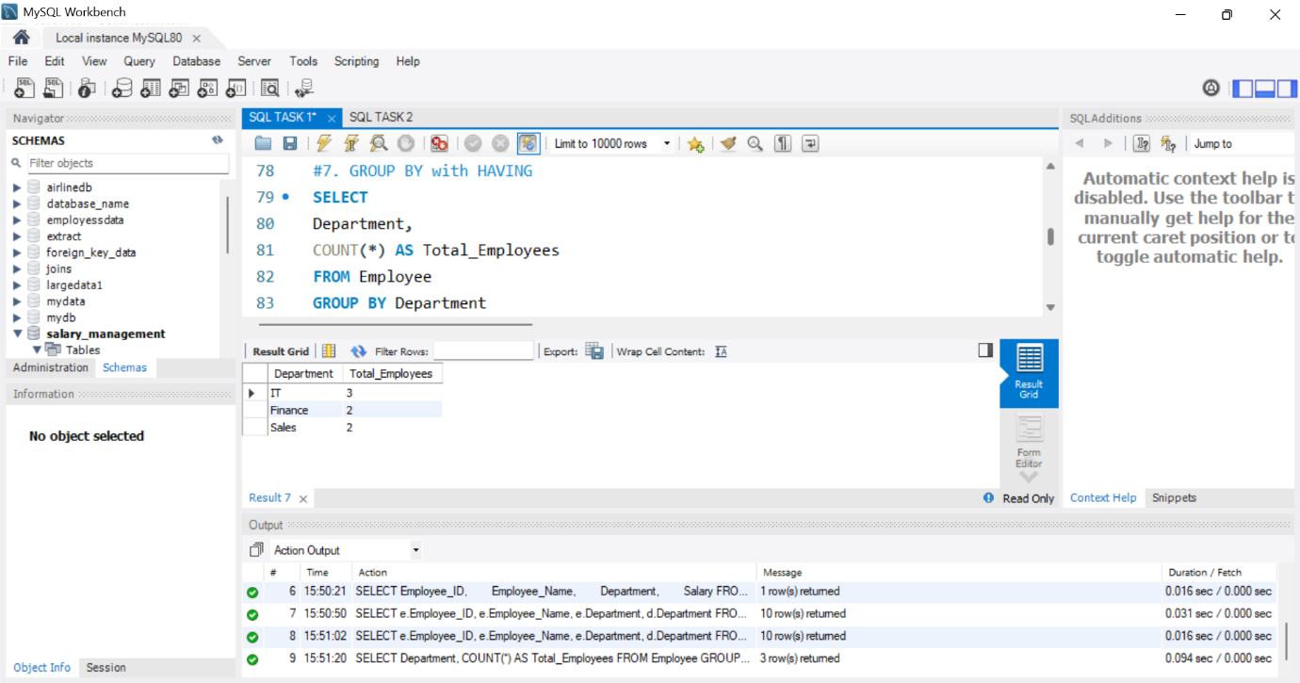

#8. Employees Hired Within the Last 6 Months
SELECT *
FROM Employee
WHERE Hire_Date >= DATE_SUB(CURDATE(), INTERVAL 6 MONTH);

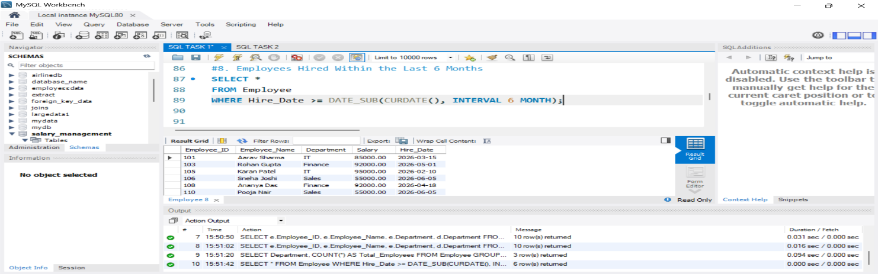
#9. Find Duplicate Records
SELECT
Department,
Salary,
Hire_Date,
COUNT(*) AS Duplicate_Count
FROM Employee
GROUP BY Department, Salary, Hire_Date
HAVING COUNT(*) > 1;

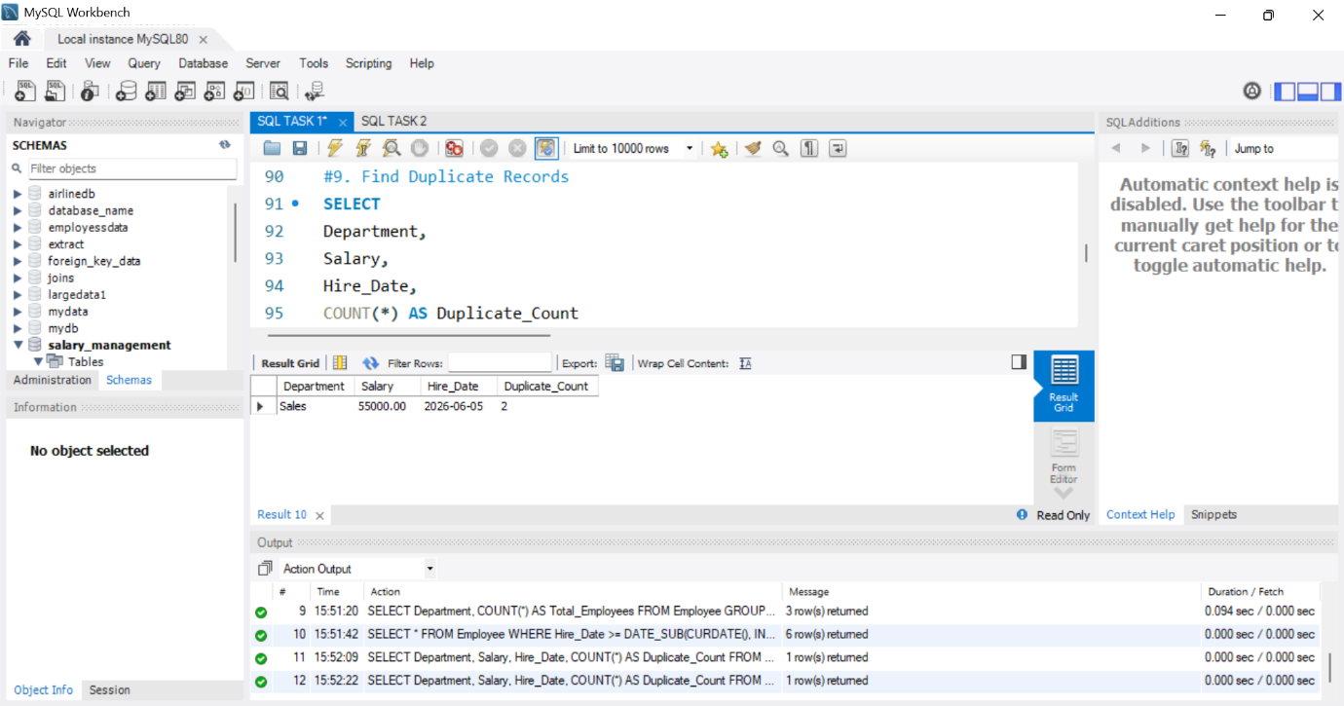

SET SQL_SAFE_UPDATES = 0;

#10. Remove Duplicate Records
DELETE e1
FROM Employee e1
JOIN Employee e2
ON e1.Employee_Name = e2.Employee_Name
AND e1.Department = e2.Department
AND e1.Salary = e2.Salary
AND e1.Hire_Date = e2.Hire_Date
AND e1.Employee_ID > e2.Employee_ID;

